

**“Project Plan and Fourth Increment”**

**“Spring 2017”**

# “Submitted by **Team 13”**

Onica Sai Prasanna Lakshmi, Rayineedi– 80

Venkata Krishna, Podili– 72

Mamatha Yadav, Chekuti– 11

Sreelekha Reddy, Kommareddy– 45

## “1. Introduction”

### “City Guide”

When people keep travelling to different places, there is always a limitation of information about the place they are travelling to. Therefore, this encouraged us for a travel guide mobile application as smartphones are evolving exponentially and becoming popular to offer greater services to multiple users using their Geo-Location etc. The tourists will be able to explore many new tourists’ places just by viewing the information in the application. This will also enable easy travel planning by knowing the Places, Events and developments happening all around the Visited Location of the user.

## “2. Project Goal and Objectives(revised)”

### “2.1 Overall Goal:”

The Main Objective of this Application is to create a user-friendly Android based Application which enables users to know about places and areas instantly that they are not familiar with and provide them with the proper information about Places, Events, Restaurants, and Transport Facilities available in that location.

### “2.2 Specific Objectives (Problem Statement):”

* Depending on the User Location, Tourist Attractions in a place can be displayed
* Entire information such as Location, address etc. of a place can be viewed
* User can schedule his visit to a place, event, or restaurant
* User will get notifications for the scheduled events

### “2.3 Specific features:”

2.3.1ThisApplication enables the user to retrieve the information such as places to visit, Food & restaurant availability, Events occurring, Transport facility available in that place.

2.3.2 After Tourist Attractions got displayed, the user can select a place from the list of attractions after which entire details such as location, contact information, and address along with select date and time attributes will get displayed

2.3.3 This is associated with My Schedule which allows to view his upcoming or current schedules

2.3.4 The user can get the notifications regarding the scheduled events

### “2.4 Significance:”

* The information in the application can be shared among tourists instantly and analyzed by the shared ones.
* The main disadvantage of insufficient information of the resources, untapped opportunities for tourism companies and the enhancement of the travel experience is overcome by providing meaningful insight for the trips.
* It provides connectivity to many smart applications for travelers.
* It provides Google’s information and resource source for marketers.

## “3. Project Plan”

### “1. Zen-Hub Screenshots:”

In this fourth increment, we created four Milestones that is., for Increment-1, Increment-2, Increment-3, Increment-4. Under Increment-4 we have issues regarding Zen-Hub, User Stories and test Cases, Notification manager, Search, UML diagrams and Designs

#### “Mile-Stones Created:”

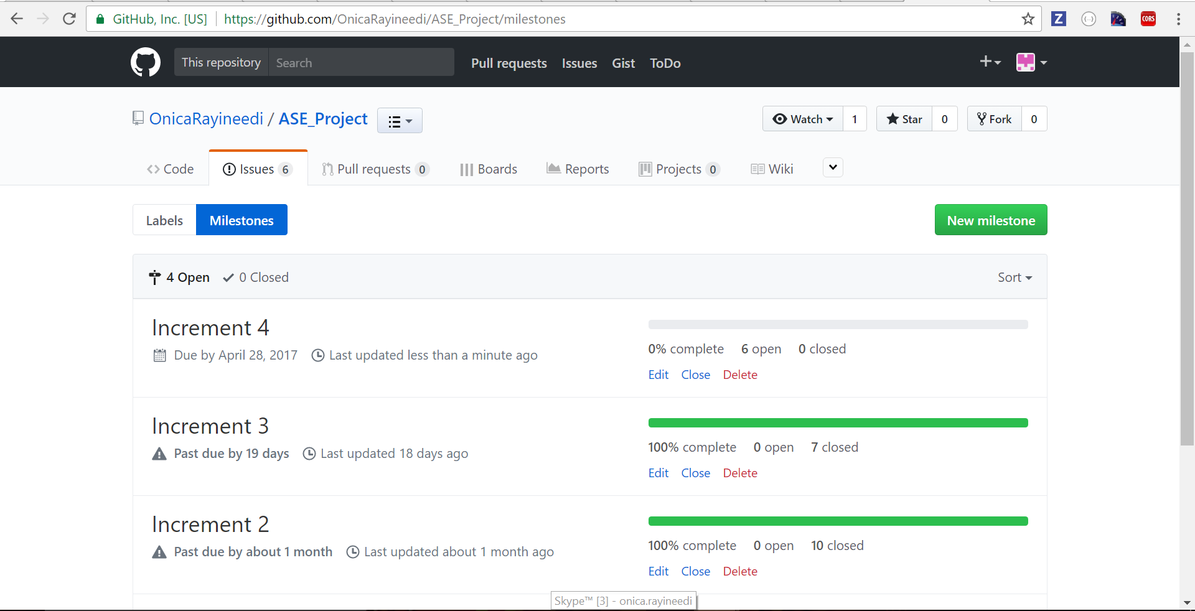

**“Issues Created:”**

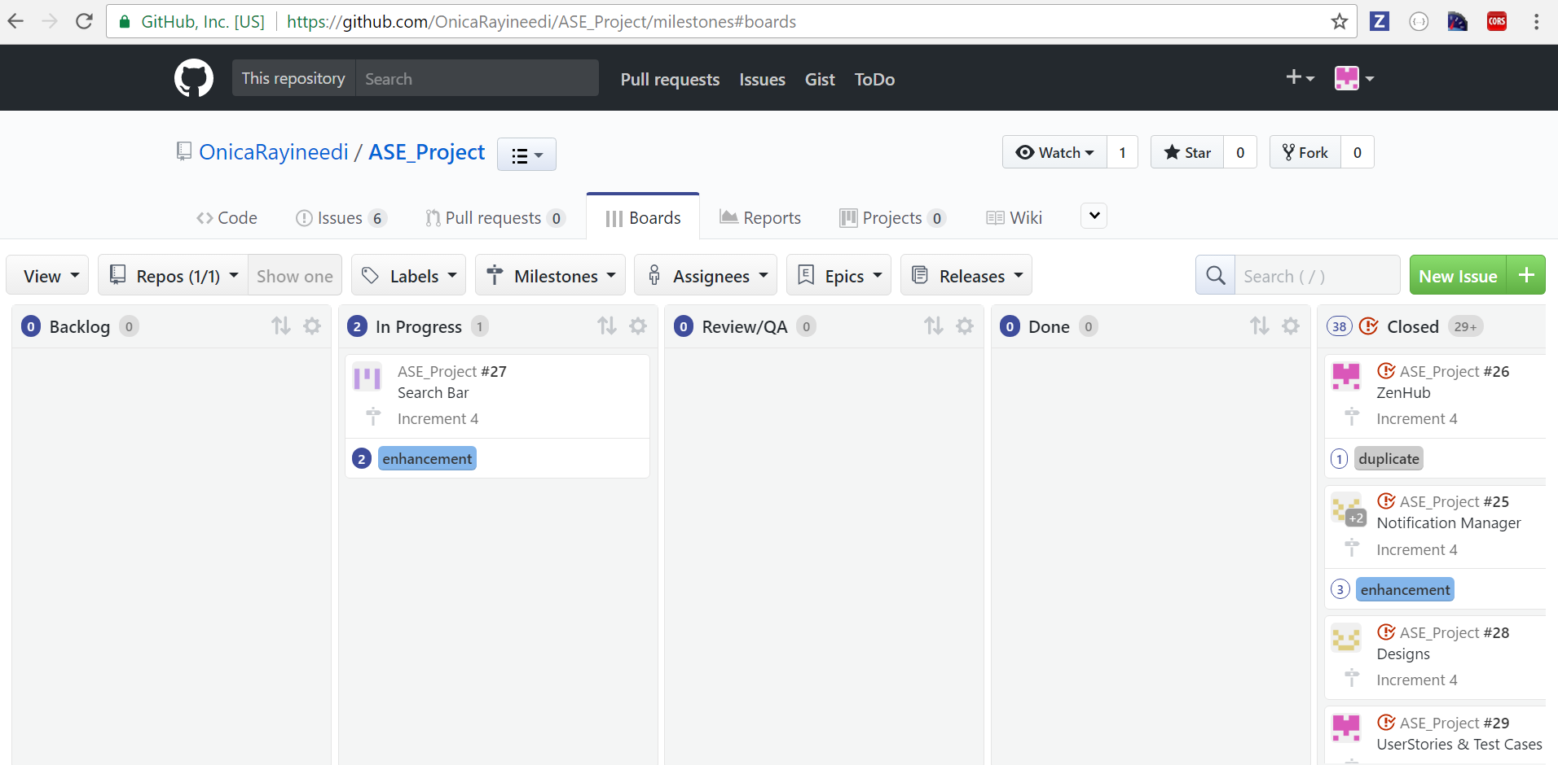

### “2. Project Timeline, Members, and Task Responsibility:”

For this Increment, there are seven issues created and below screenshots describe how tasks been assigned to the team members

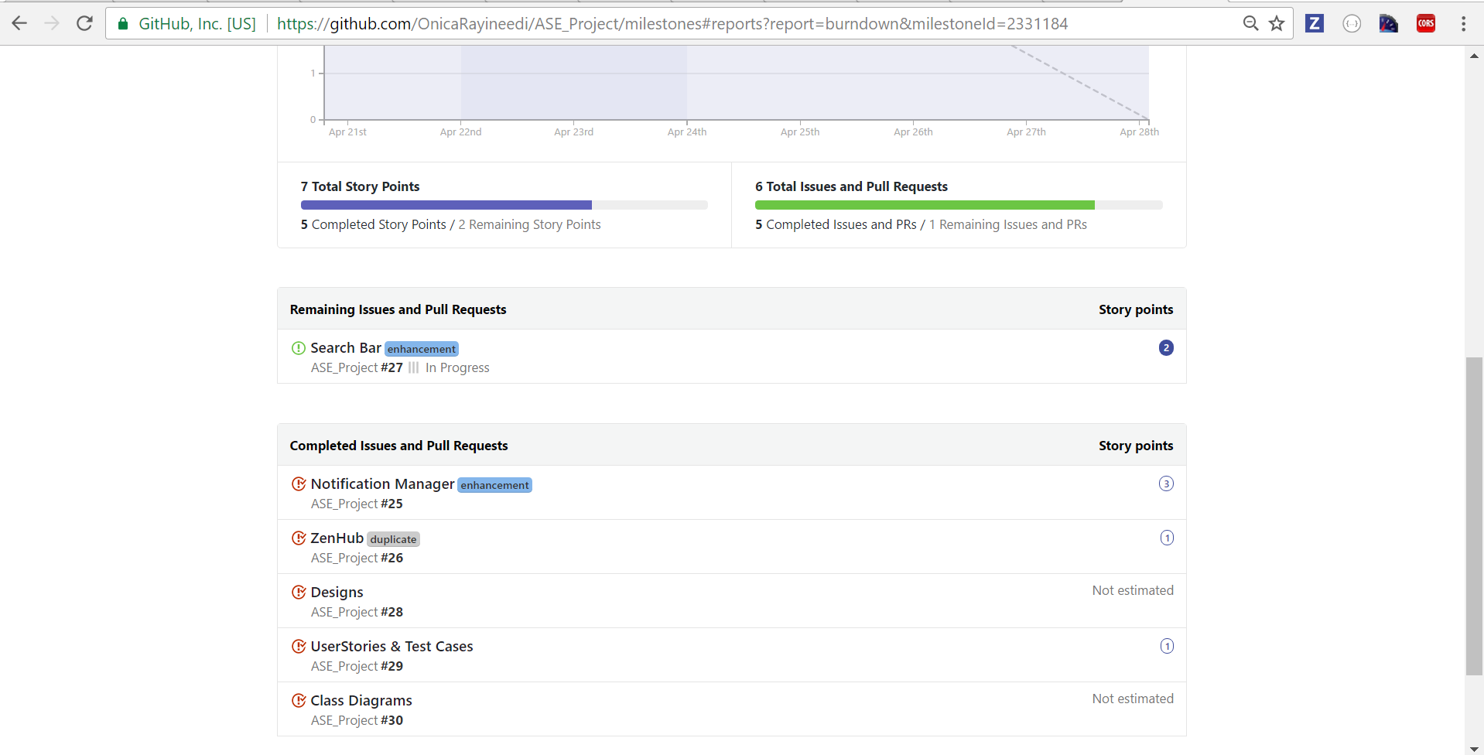

### “3. Burn-Down chart:”

This Burn-Down chart is generated for Increment-4 which the above designed issues created

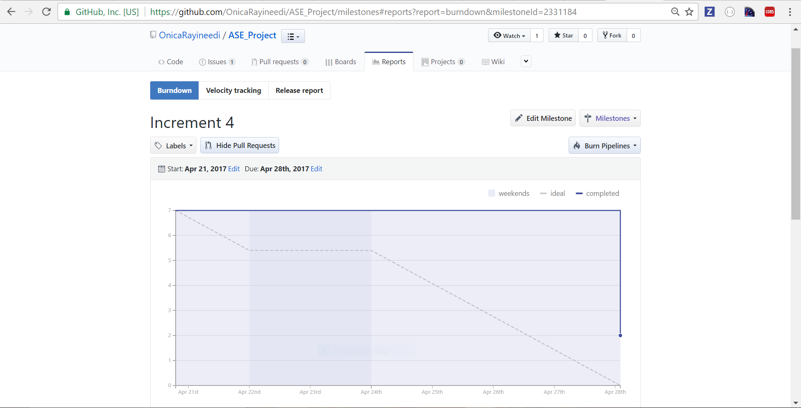

## “4. Fourth Increment Report”

### “4.1 Existing Services/REST API:”

* Facebook API
* Foursquare API
* M-Lab
* Google-Maps

### “4.2 Detail Design of Features:”

### “4.2.1. Wireframes:”

* **“Login Page:”** A Login Page is created with Email ID and Password as attributes.

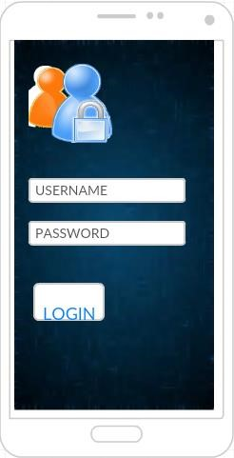

* **“Registration Page:”** A Registration Page is created with First Name, Last Name, Password, username

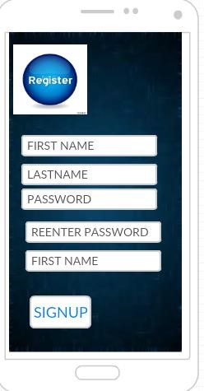

### HOME SCREEN

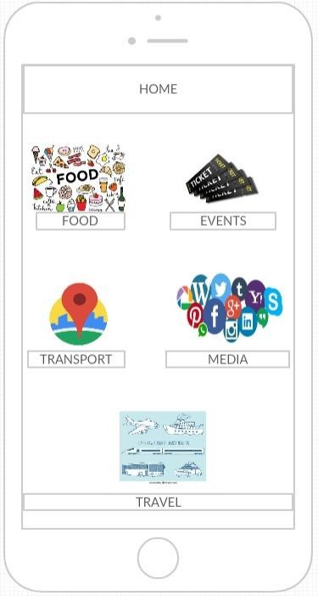

### 4.2.2 Class Diagram:”

This diagram depicts the static structure of the Application using Classes and their Attributes.

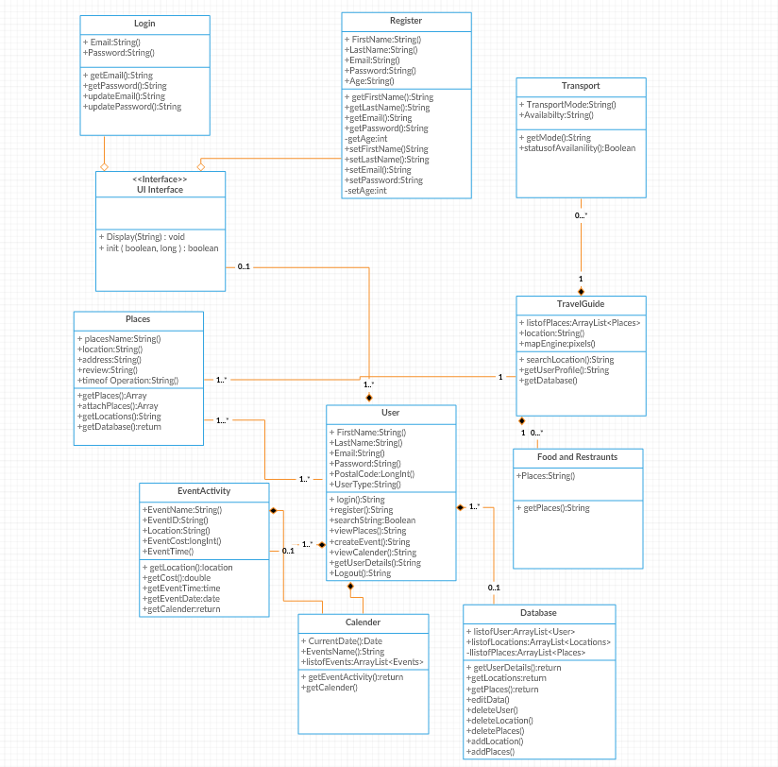

### 4.2.3 Sequence Diagram:”

This Sequence Diagram depicts the interaction mechanism of the objects implemented in the system application.

#### “Sequence Diagram for Login and registration:”

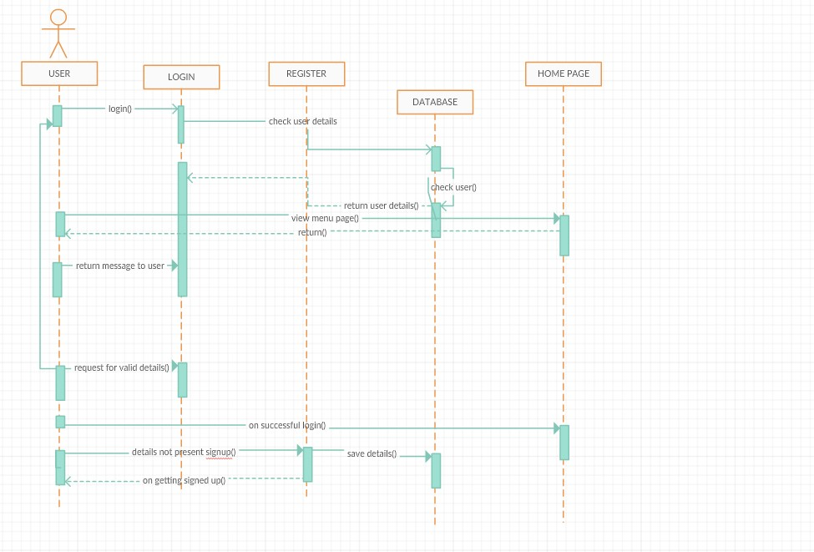

#### “Sequence Diagram for Home Page:”

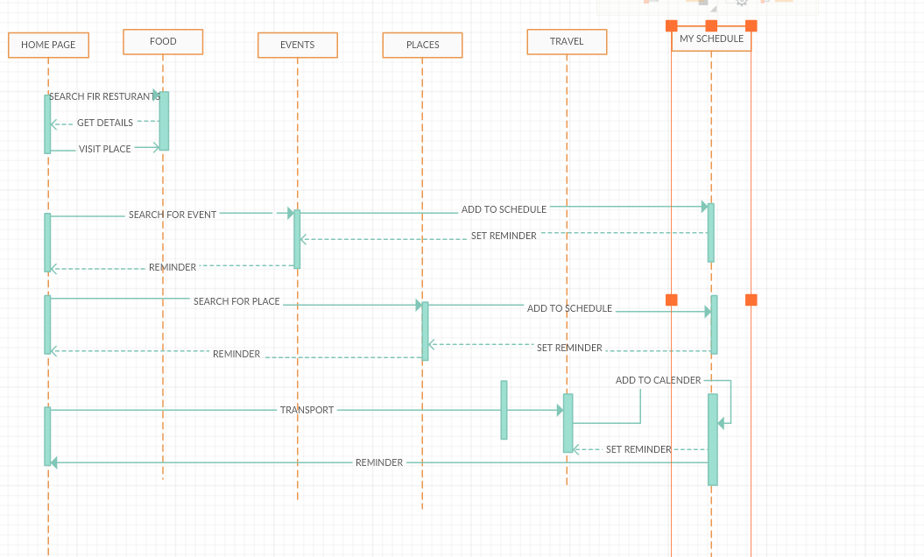

**“4.2.4 Architecture Diagram:”**

Structure and Behavior of the application is described in the system architecture.

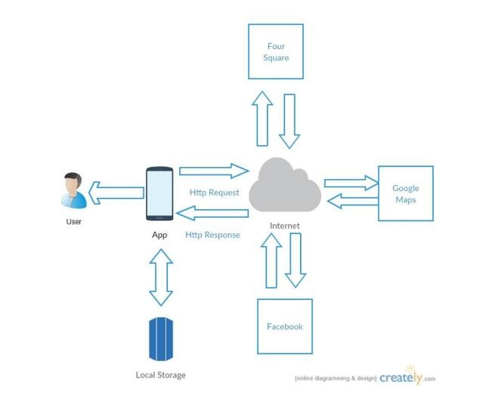

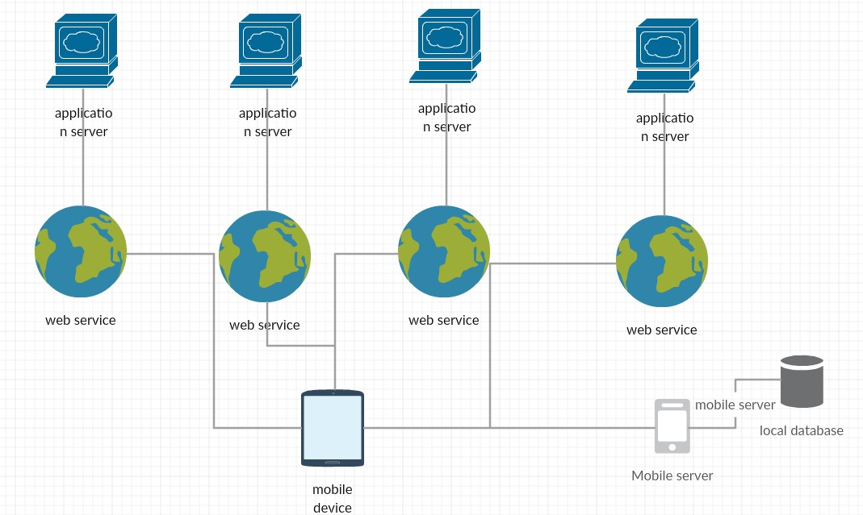

### “4.2.5 Use Case Diagram:”

Use case diagram represents the interaction of user with the application

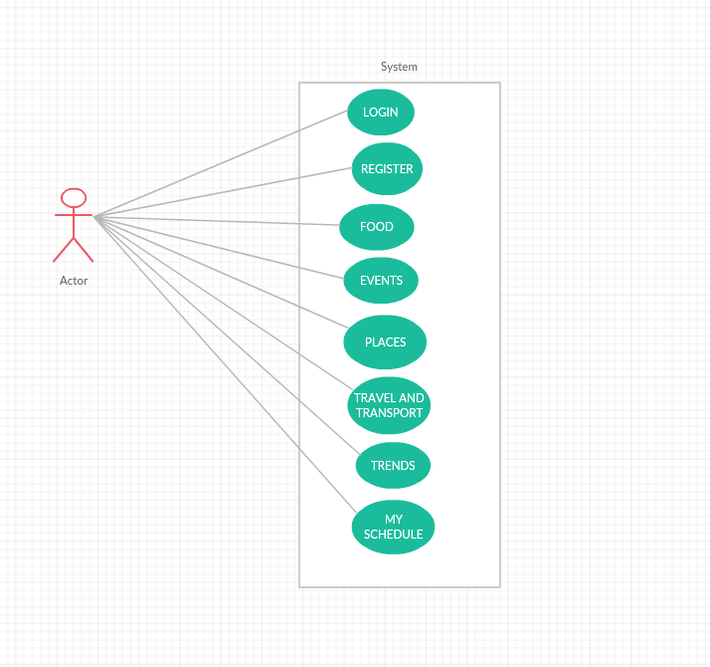

### “4.2.6 User Stories:”

|  |  |  |
| --- | --- | --- |
| As a | I want to | So, that |
| User | Search for the tourist places and events based on my location | I can visit that place as a tourist |
| Get the various Tourist Attractions located in that location | I can visit all the Tourist Attractions located in that place |
| Get Directions and navigation to the Tourist place selected | I do not have any problem in finding the location of the selected place |
| Get all the information such as contact number, Locations, images, video’s (if present) and reviews | I can gain more knowledge about that place |
| Get all the details about Basic Amenities present in that place | I do not face any problem by visiting that place |
| To schedule events and update calendar | I can view the dates and events planned on that days (such as visiting a place) |
| To get the Notifications about scheduled events | I can review the added events |

### “4.2.7 Unit Testing:”

|  |  |  |  |
| --- | --- | --- | --- |
| Case | Test Case Description | Expected Result | Actual Result |
| Events Search | On searching the location | Display the nearby events | PASS |
| Places Search | On searching the Location | Display the nearby visiting spots | PASS |
| Get Directions | On clicking on a location | Display G-Maps linked with the location along with the address and Contact Info | PASS |
| Travel & Transport | On searching the Location | Display places to live and transportation facilities | PASS |
| Food | On searching the Location | Display nearby restaurants | PASS |
| Receive Notifications | On Scheduling Events | Receive Notifications on Scheduling Events | PASS |

**“4.3 Design Patterns:”**

* In this Android Application, observed design patterns are “Façade Design Pattern” which is the “Structural Design Pattern” for Android Applications and “Singleton Design Pattern” which is the “Creational Design Pattern”.

**“Façade Design Pattern – Structural Design Pattern:”**

* It provides an interface which makes other interfaces easier to use. Here is the Diagram which describes the functionality of this design pattern.

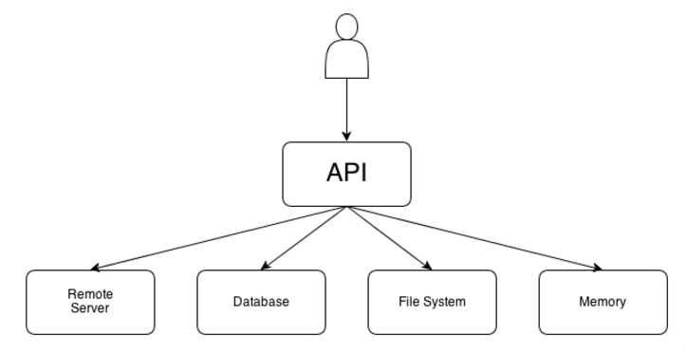

* Here, we need List of Places, Restaurants, Events, and Transport details. This Activities should ask a single object without even understanding the innerworkings of cache and API Client.
* If there any changes to be done with in the implementation of API, Activity will not get effected

**Example code:**

If the User wants to get List of books from an API

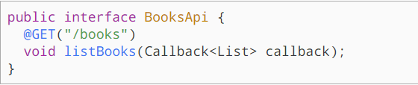

**Code Implemented in Application:**



**“Singleton Design Pattern – Creational Design Pattern:”**

* Here, Class should have only one instance and provides the global point of access
* Encapsulated “Just-in-time initialization” or “initialization on the first use”
* Here, in this Application we use this design pattern for Logging in into the application, as we have unique mail ID’s and Passwords for all the users.
* Global Access is also Provided

**Structure:**

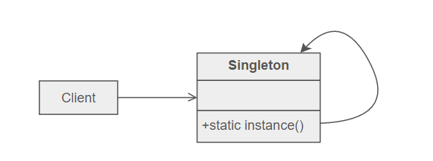

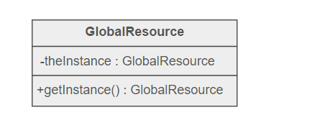

**“5. Implementation and deployment:”**

Android Application which we developed till date has been designed using android studio and result is observed using emulator and in an android mobile.

### “Screen Shots:”

* By opening the Application in the android mobile following login page will be displayed which has email and password as attributes.
* If the user enters Invalid credentials, then an alert appears stating that Password do not match or Invalid Email
* If the user is new to the application, then he can register by using the registration page
* On clicking on the registration button a registration form appears
* New user should fill all the details and then by clicking on register button and get migrated to login page
* After successful registration, an alert appears with a message Success
* Then you will be navigated to the home page
* In the home page, you can find food, events, travel and transport, places, and trends icons
* By clicking on the respective icons, you can find the results accordingly
* By clicking on each results, Address and Location of the respective result will get displayed along with the G-map also choose date and time attributes are also present where the user can choose date and time to schedule his event
* Events scheduled can be viewed by clicking on My Schedule Icon
* These Events are stored in M-Lab and can be retrieved when the user clicks My Schedule Icon
* A delete button is present in extreme right which enables the user to delete the event if necessary
* Icon by clicking which application can be accessed

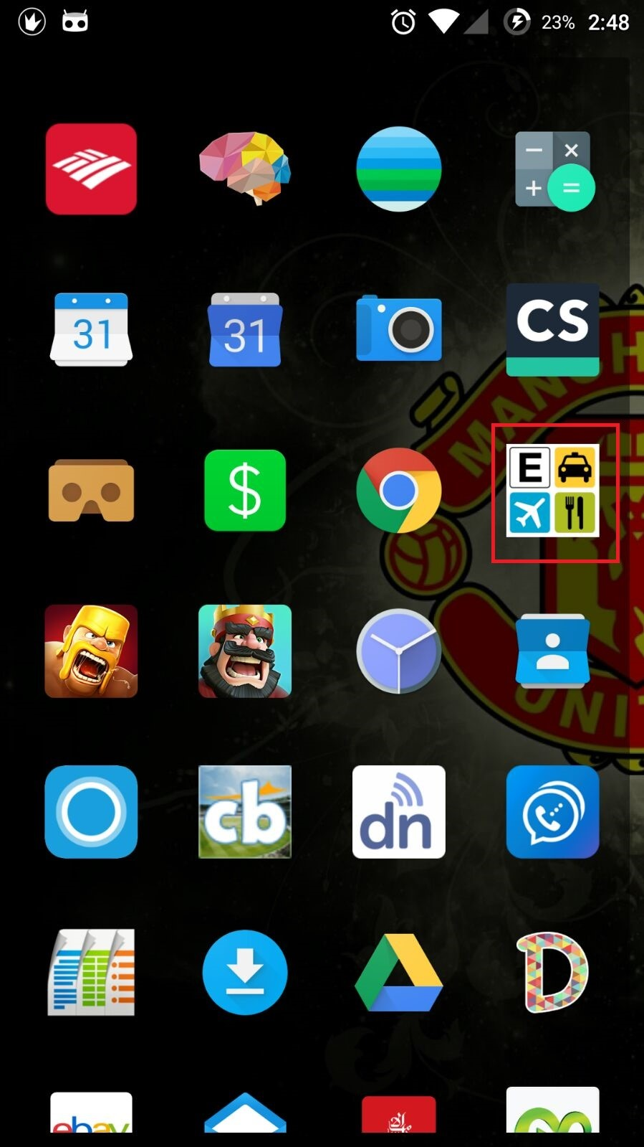

* By launching the application, A landing page is displayed which consists of Login, Register buttons along with the Facebook login button.

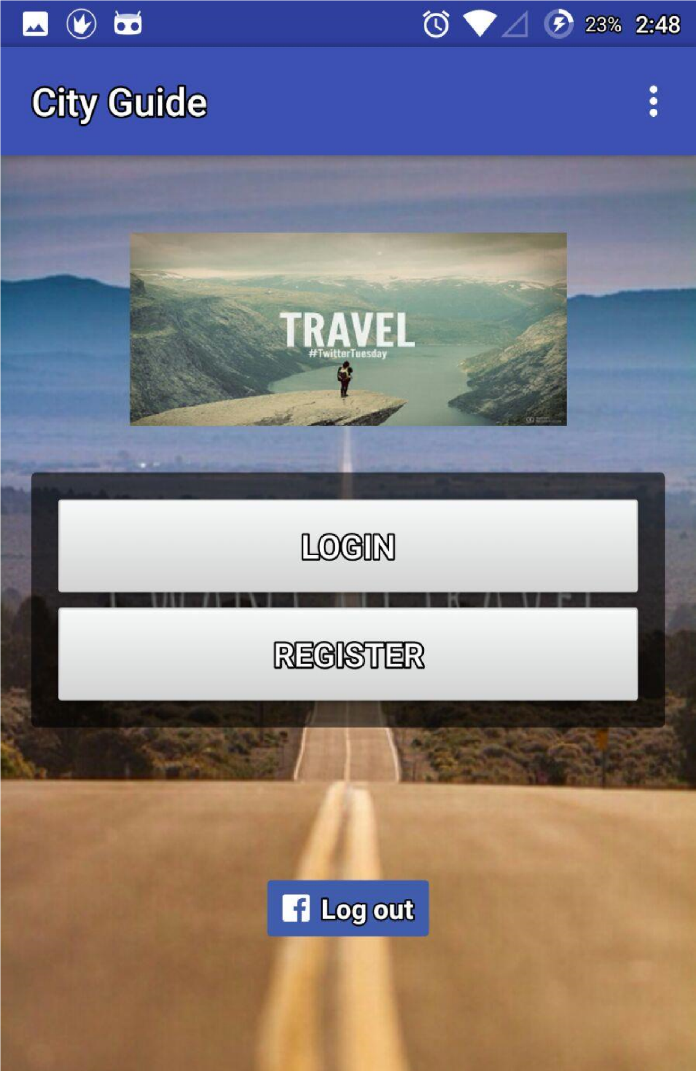

* By clicking on the Login Button the user gets navigated to the Login Page which consists of Email and Password attributes, after filling the details user clicks on login after successful login user gets navigated to the Home Page. If the user is new to the application then by clicking on “No account yet? Create one” the user gets navigated to registration page where he can register to use the application.

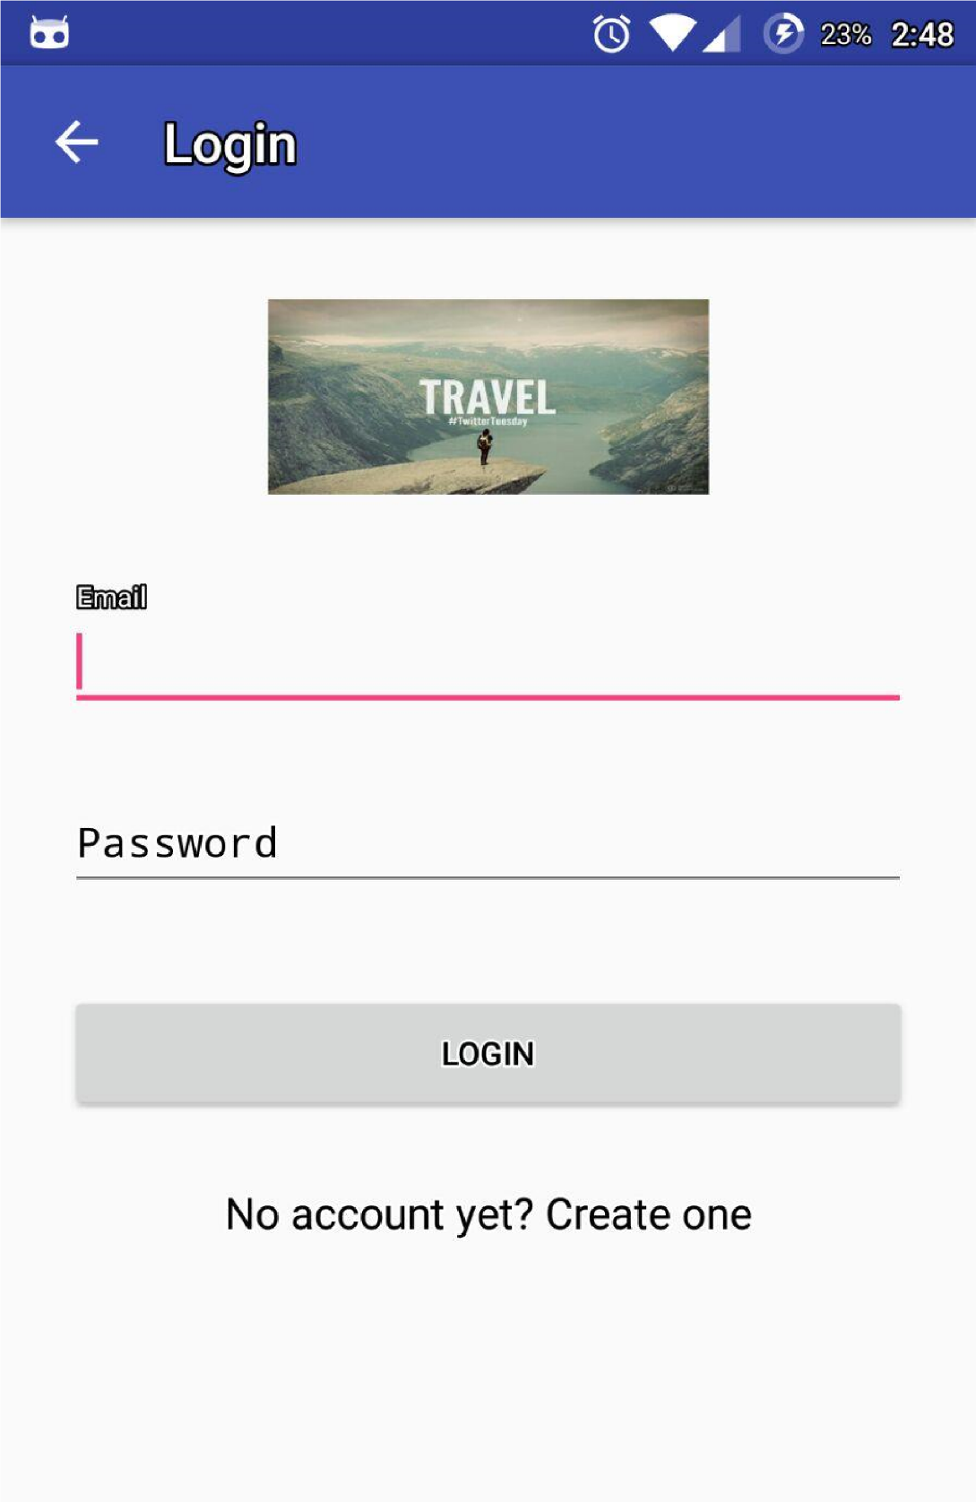

* If the user is new to application, by clicking on the Register button in the landing page he gets navigated to the registration page where Name, Email, Password, and Mobile Number attributes are present. After Clicking on the register button user gets registered and navigated to login page and after successful login he gets navigated to home page.

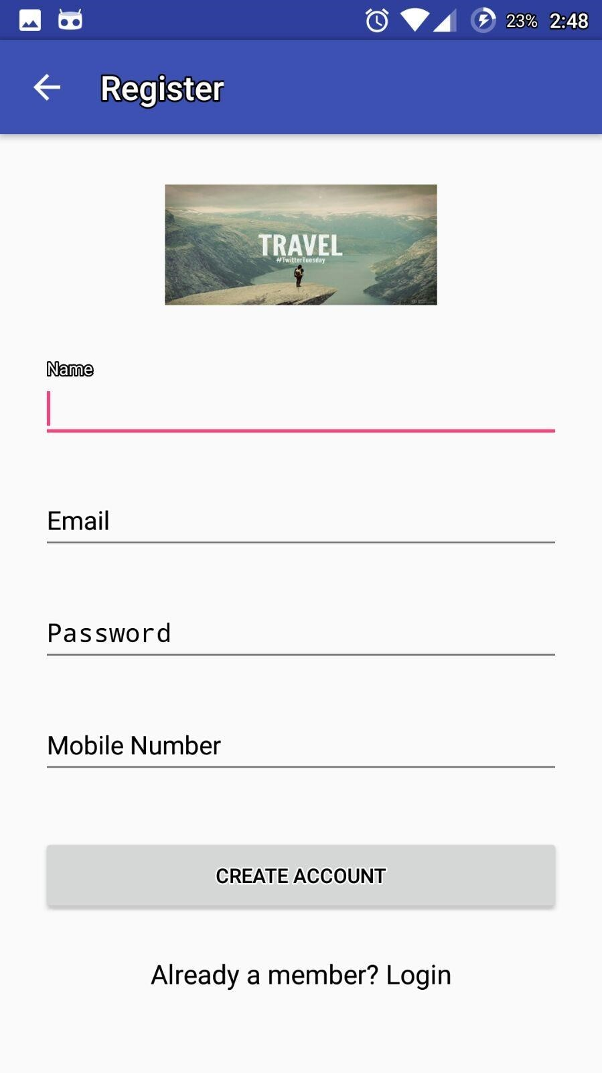

* User can also use his Facebook credentials to use the application, by clicking on the Facebook login button in landing page

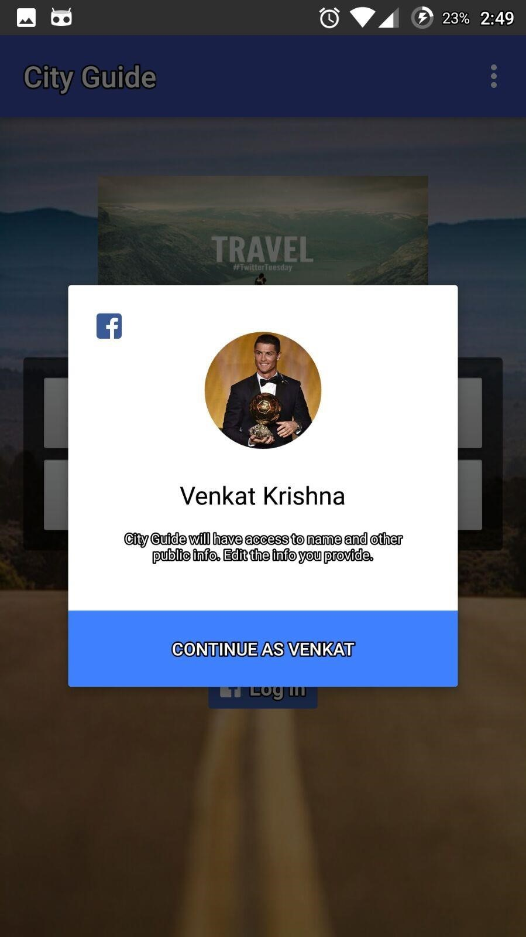

* Home page which describes the features of the application will be displayed after successful login of the user. This page consists of Food, Events, Places, Travel and Transport and My Schedule by clicking on these icons respective results will get displayed

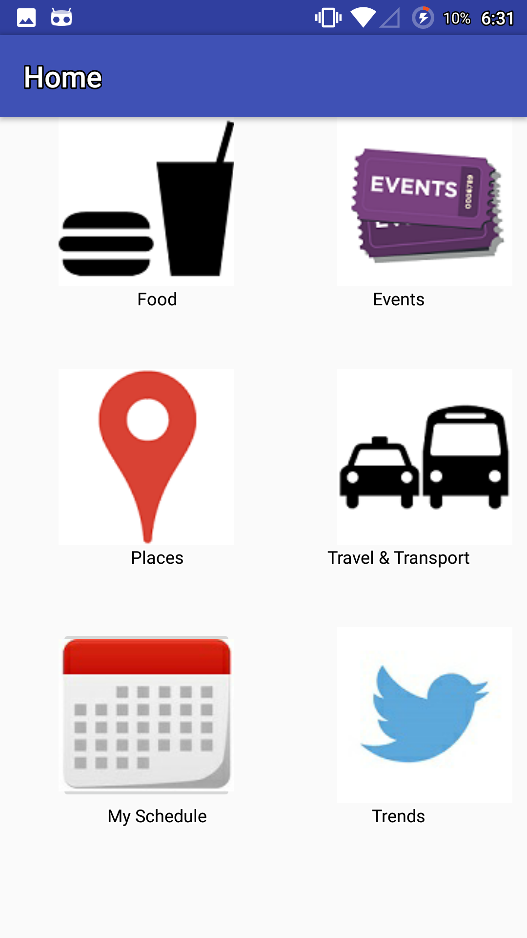

* Following are the results which will be displayed

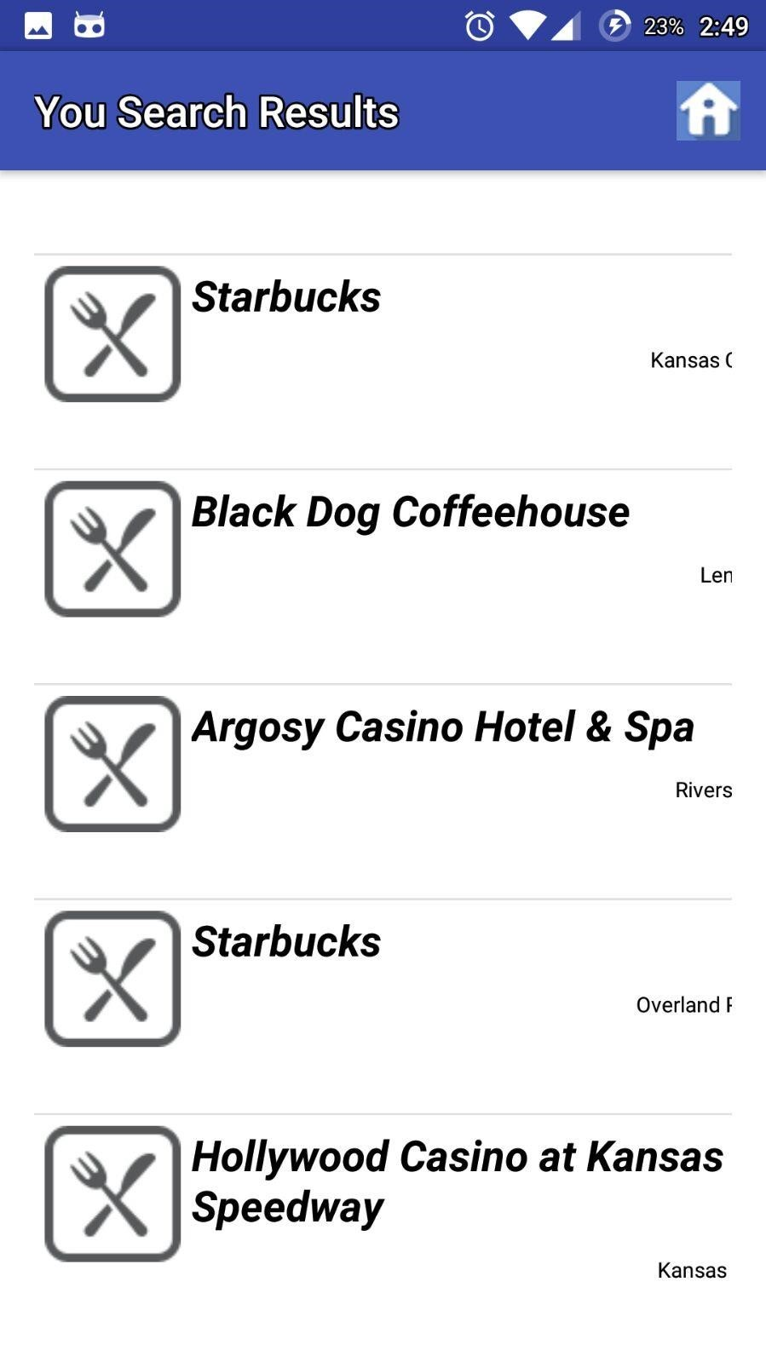

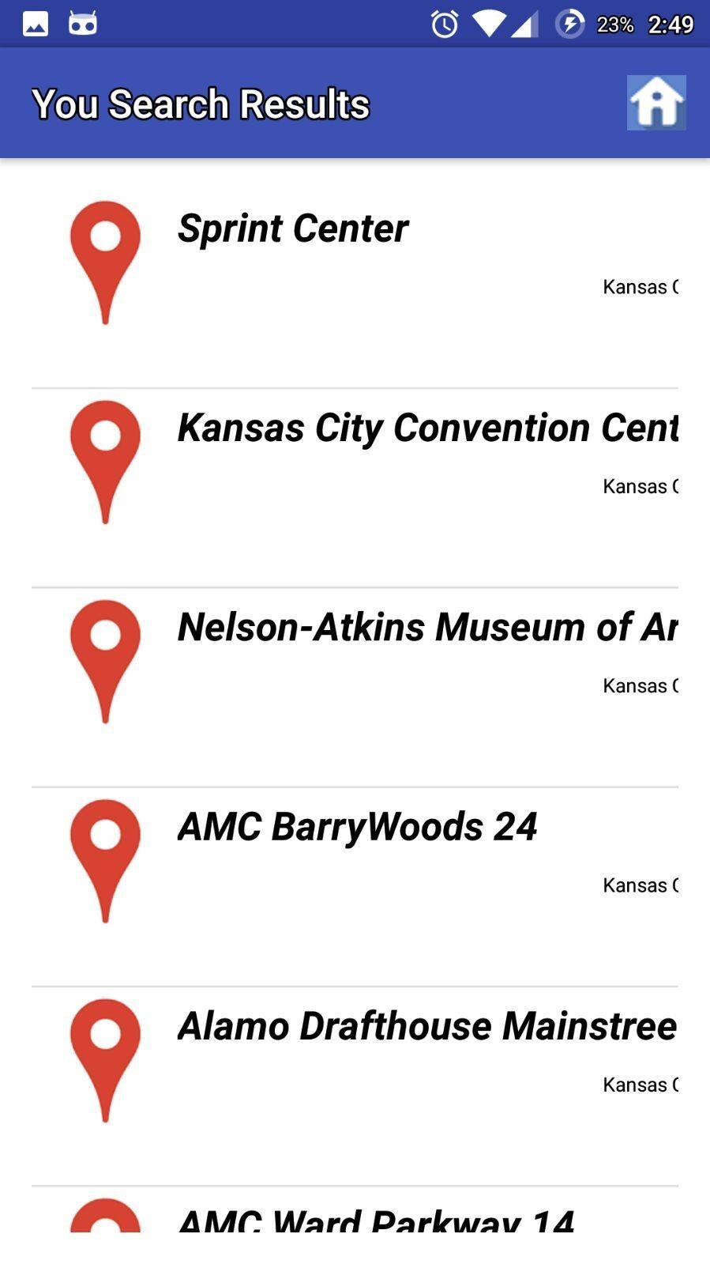

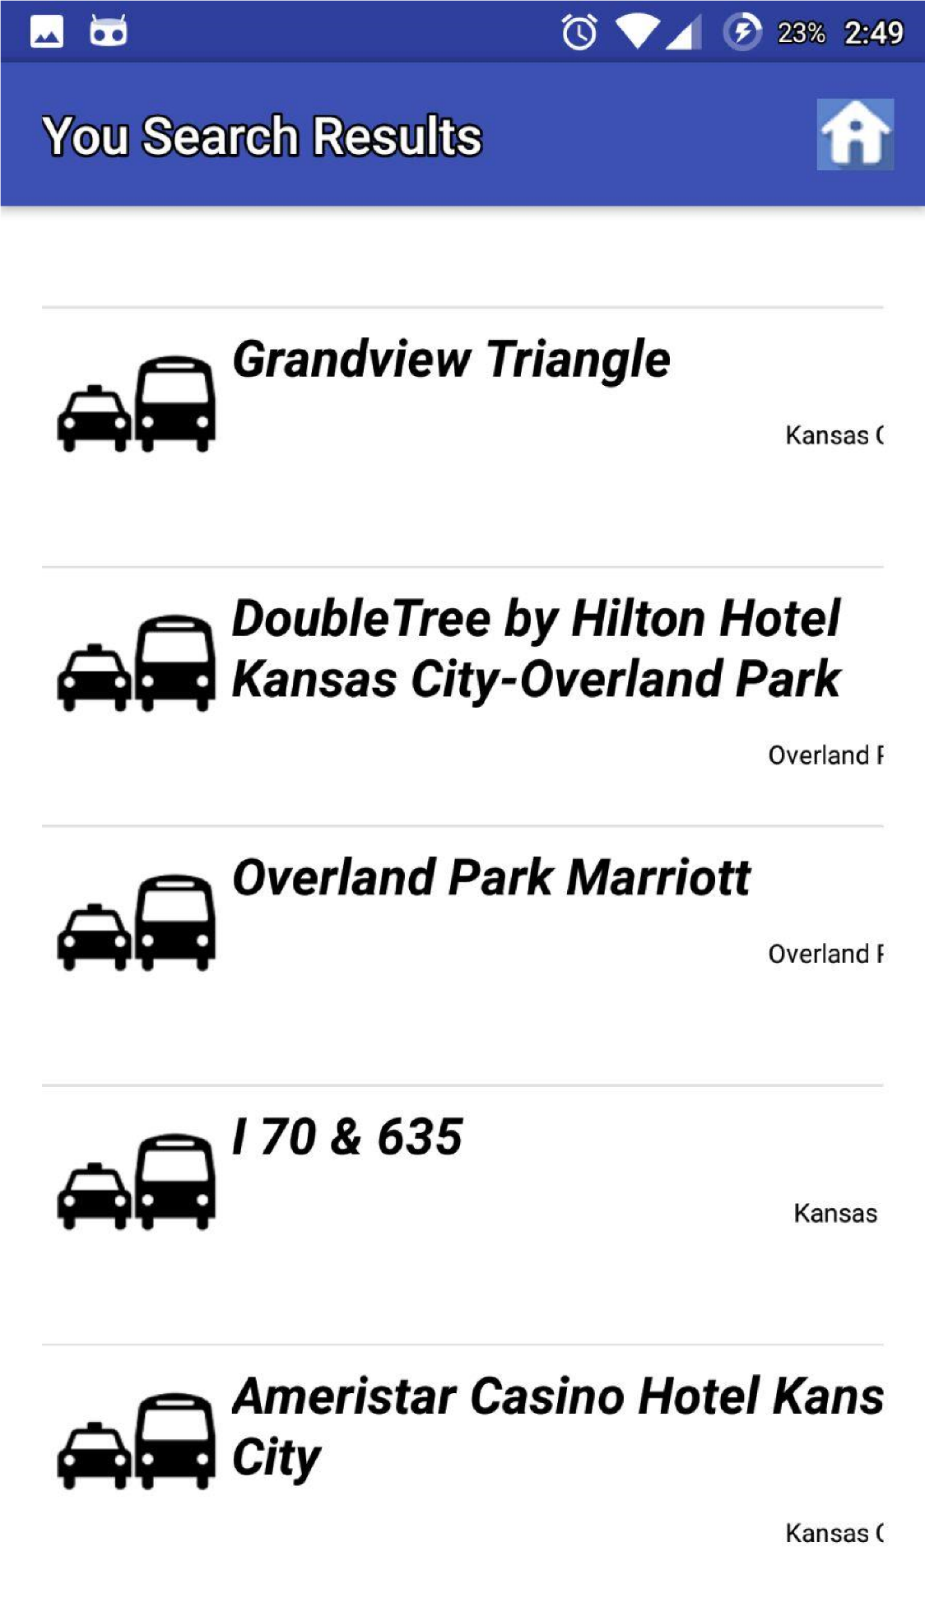

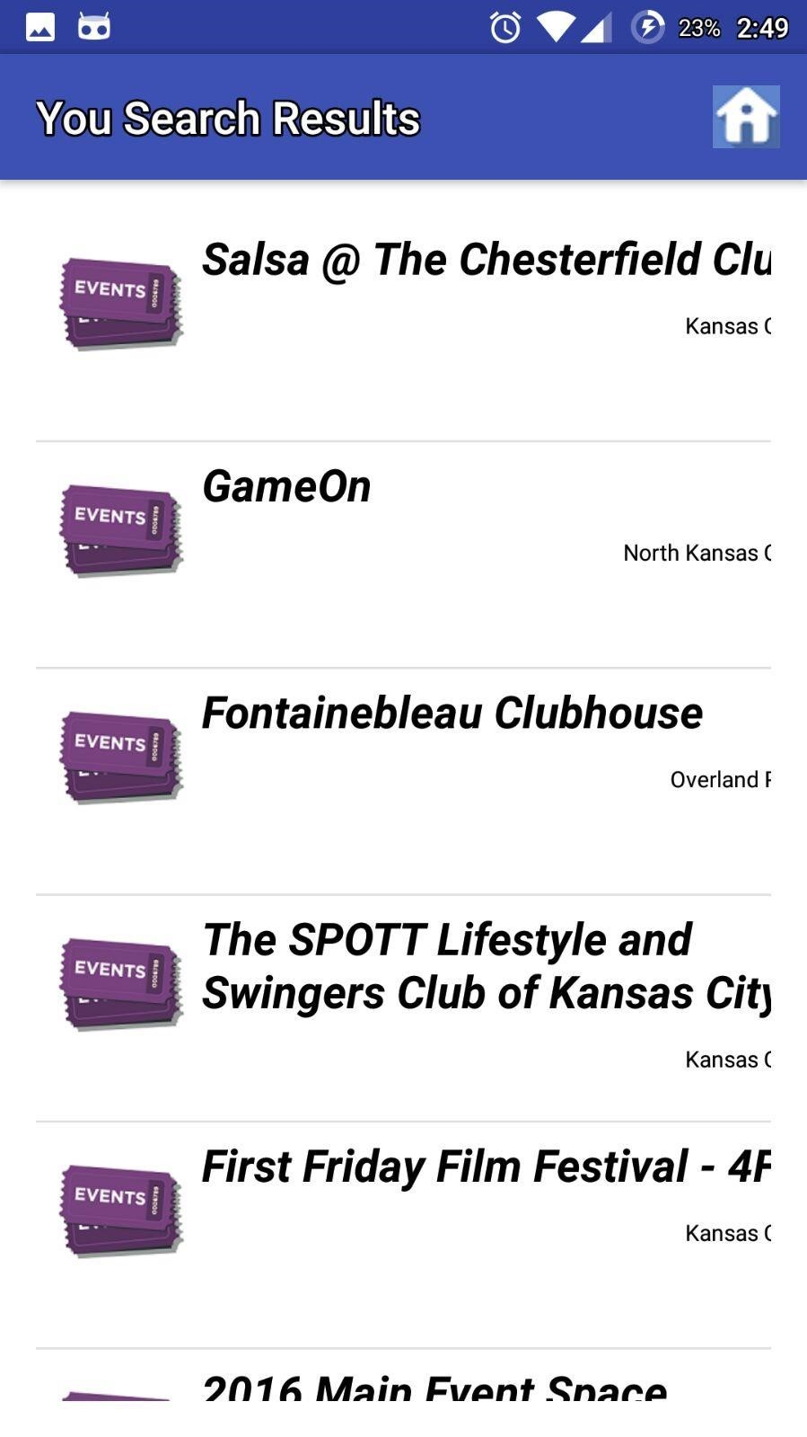

* By clicking on an event, place, or restaurant it’s address, and location on map along with the option of scheduling the event as task is displayed.

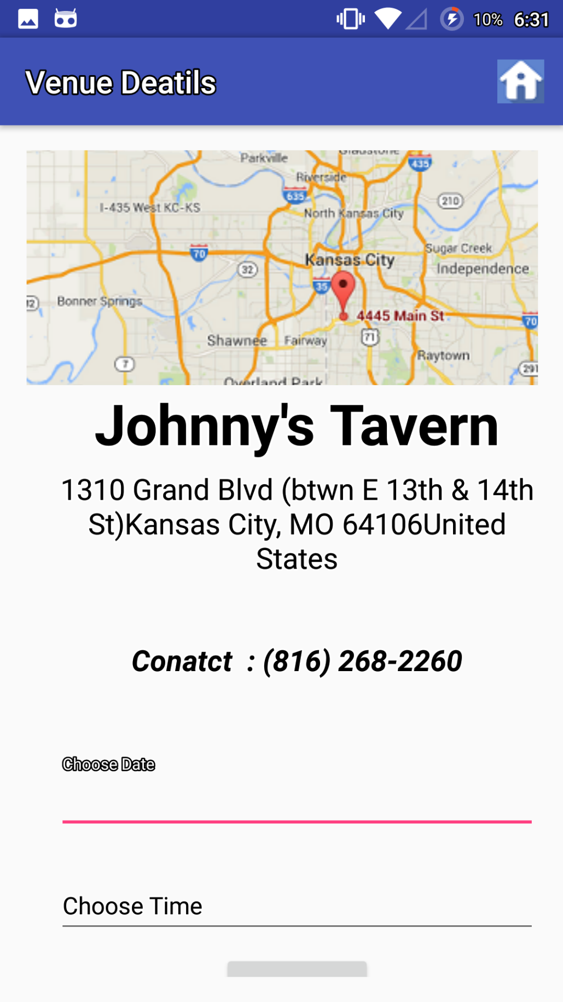

* These events can be viewed later, by clicking on my schedule icon, where a button for notification is placed and by clicking on that the user can get the notifications for the added events.

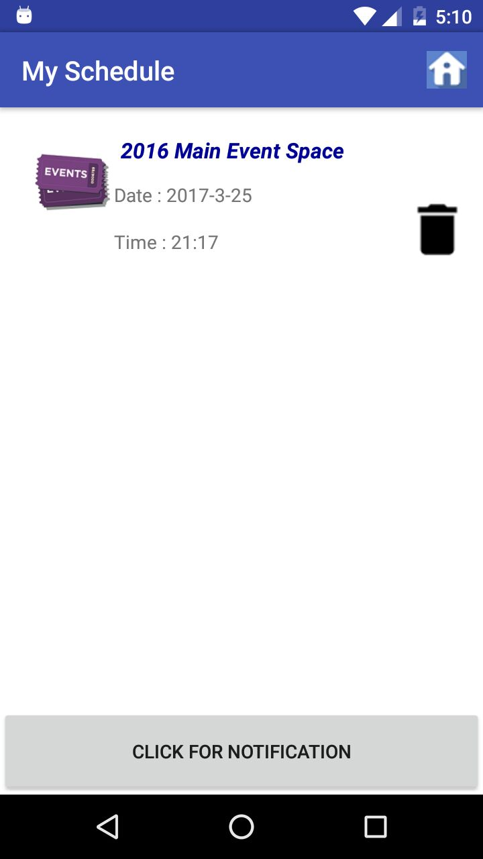

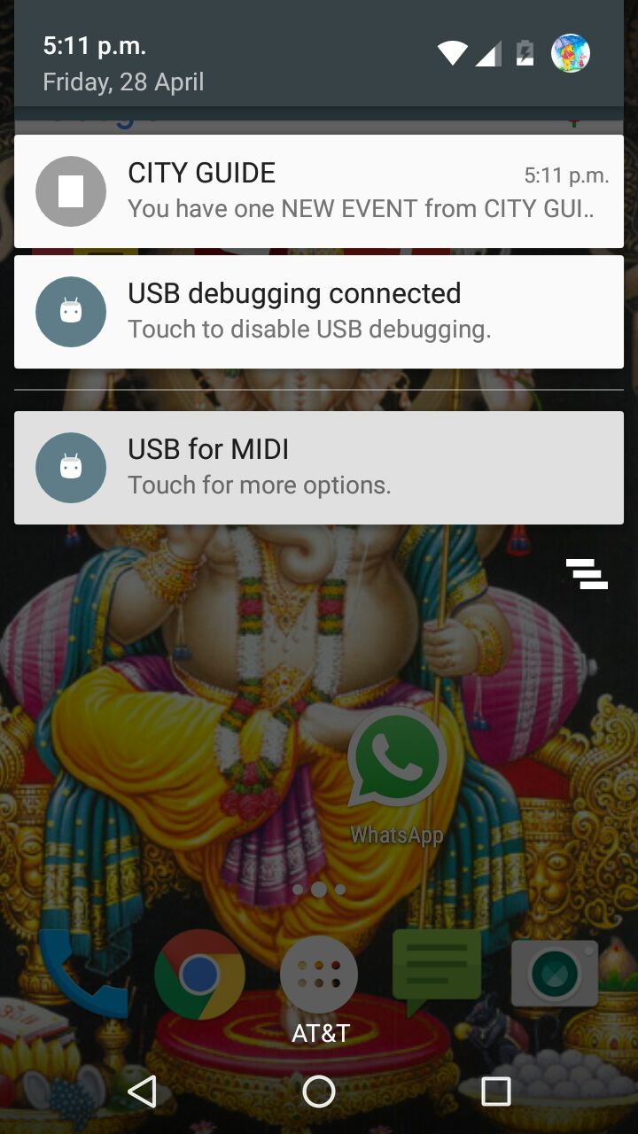

* If the User wants to search in other places other than geolocation he can do through the following page.

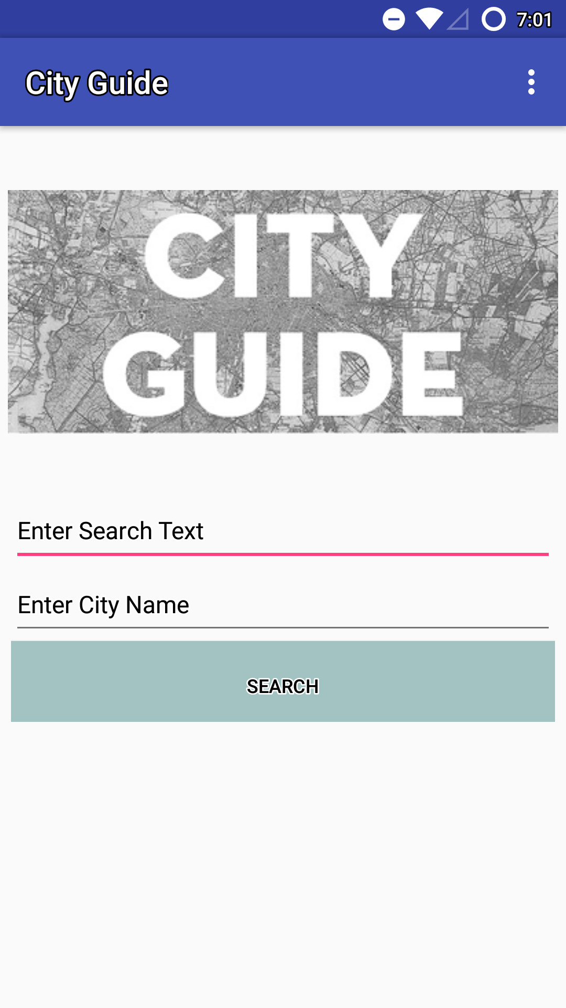

* The user can enter his search attribute and the city he wants to visit, for which results are shown below

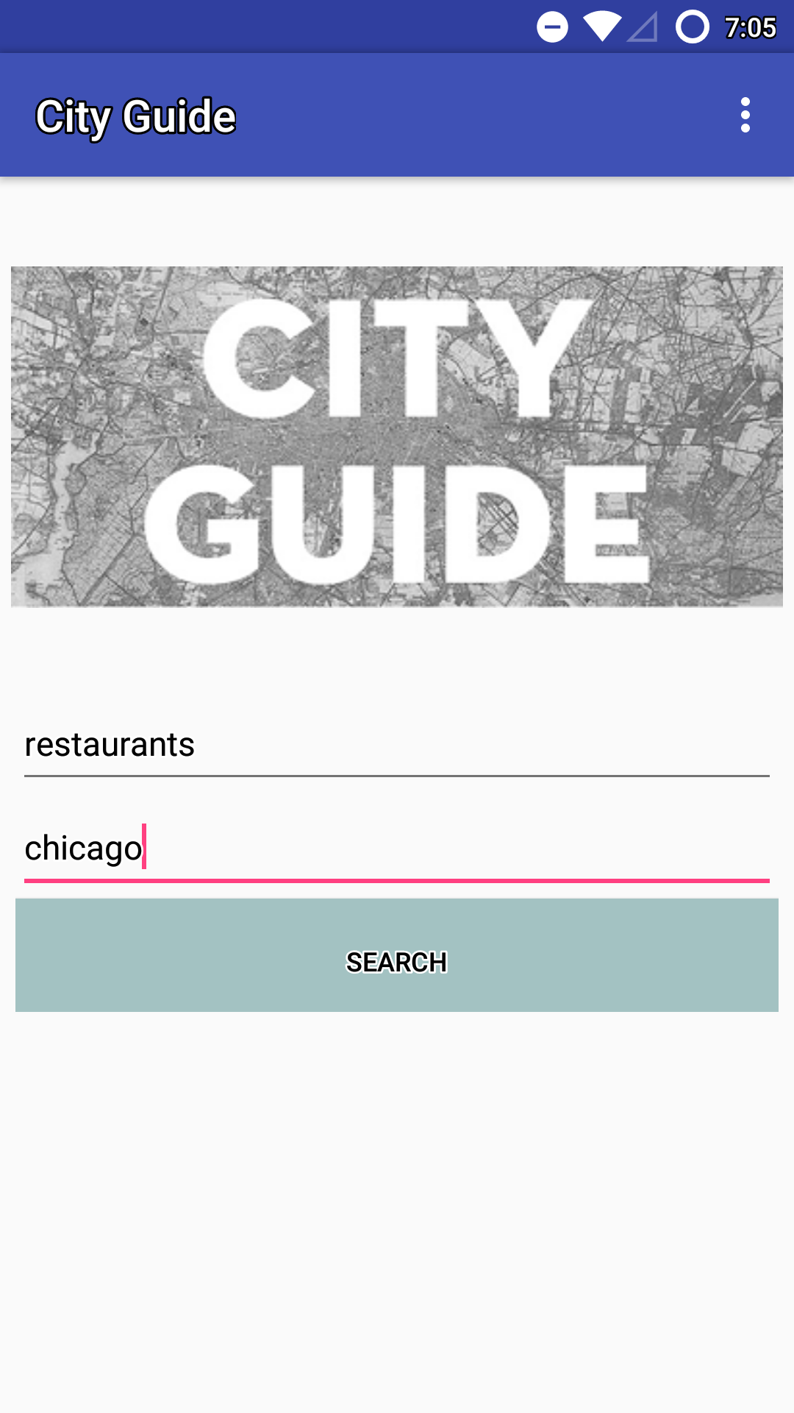

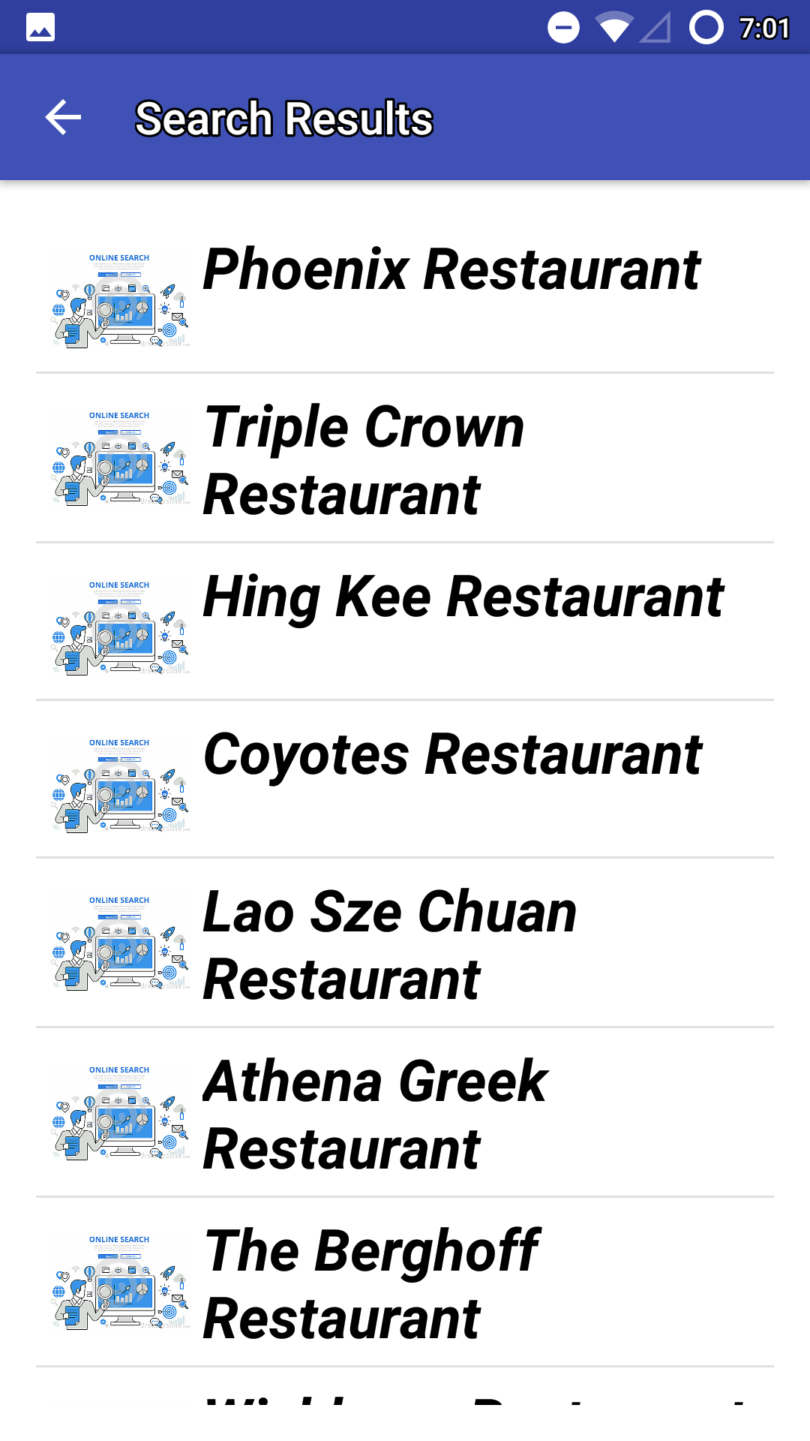

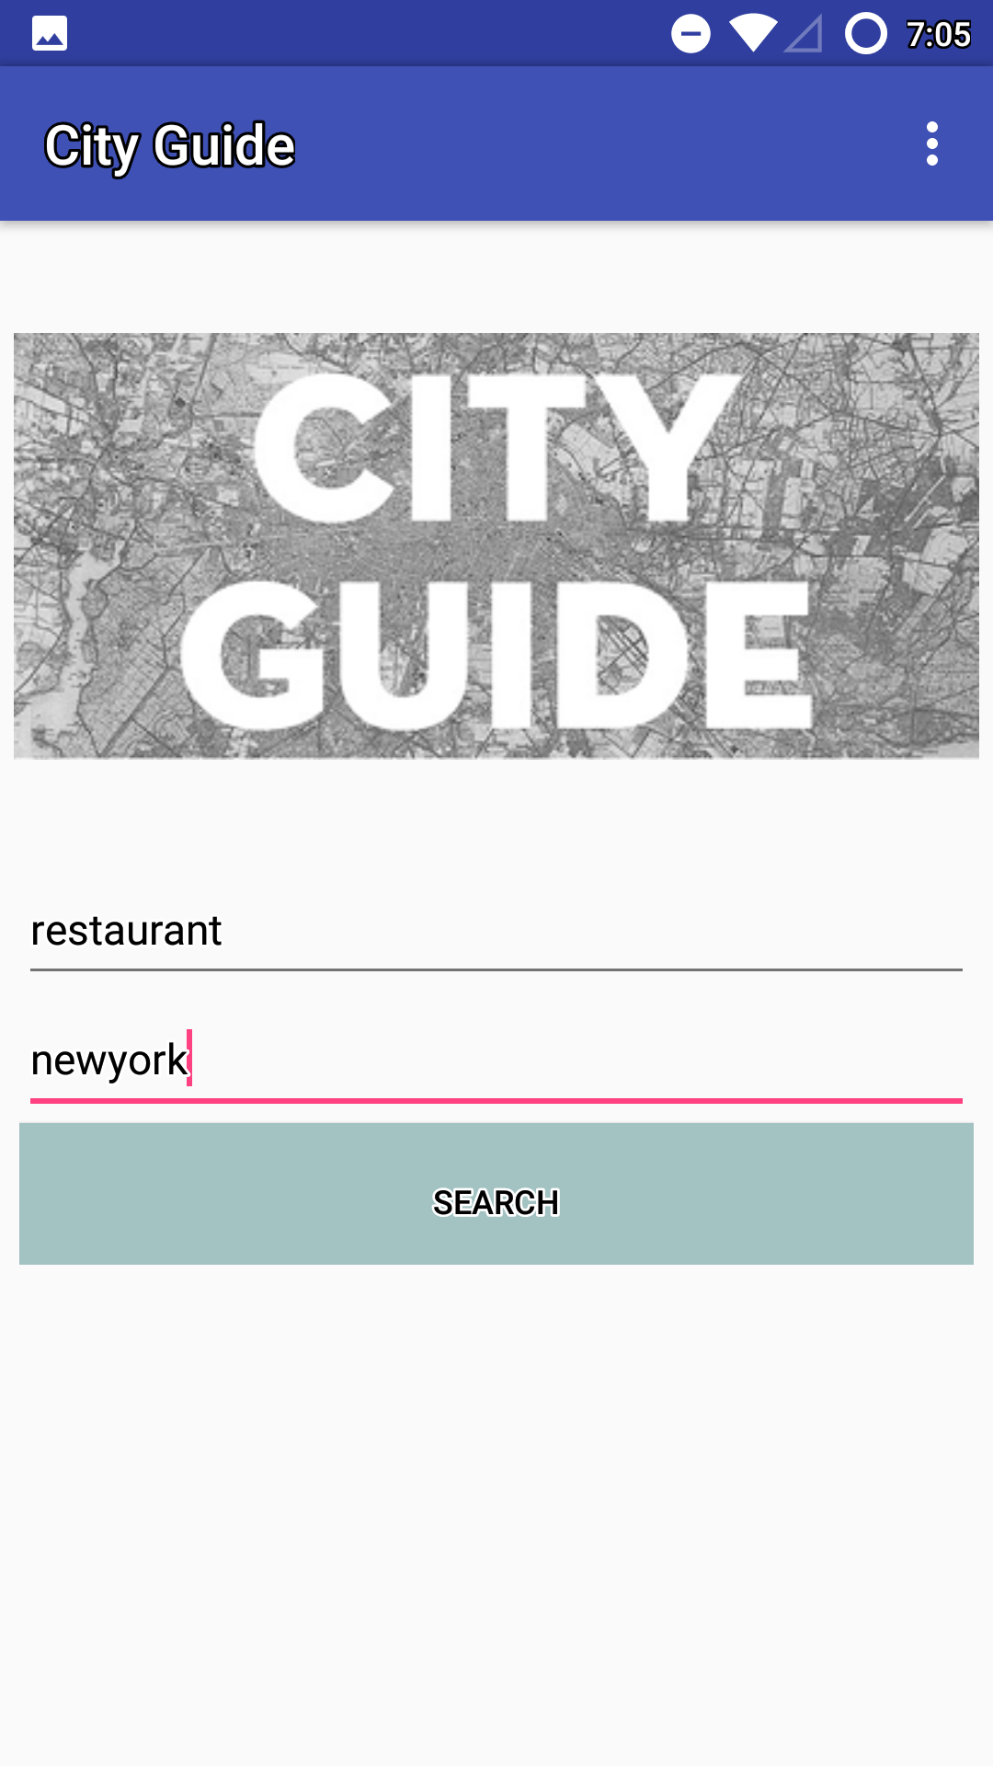

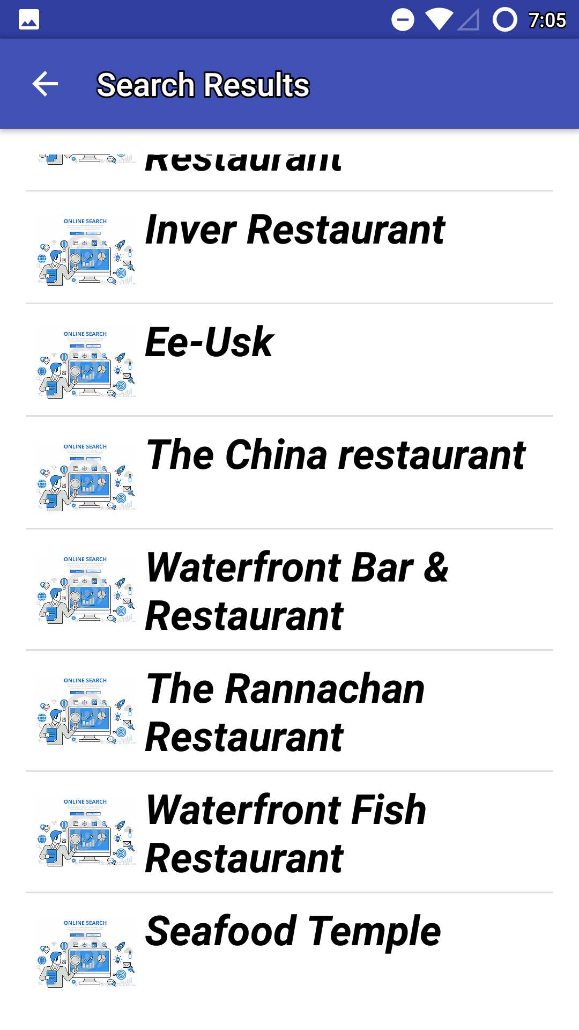

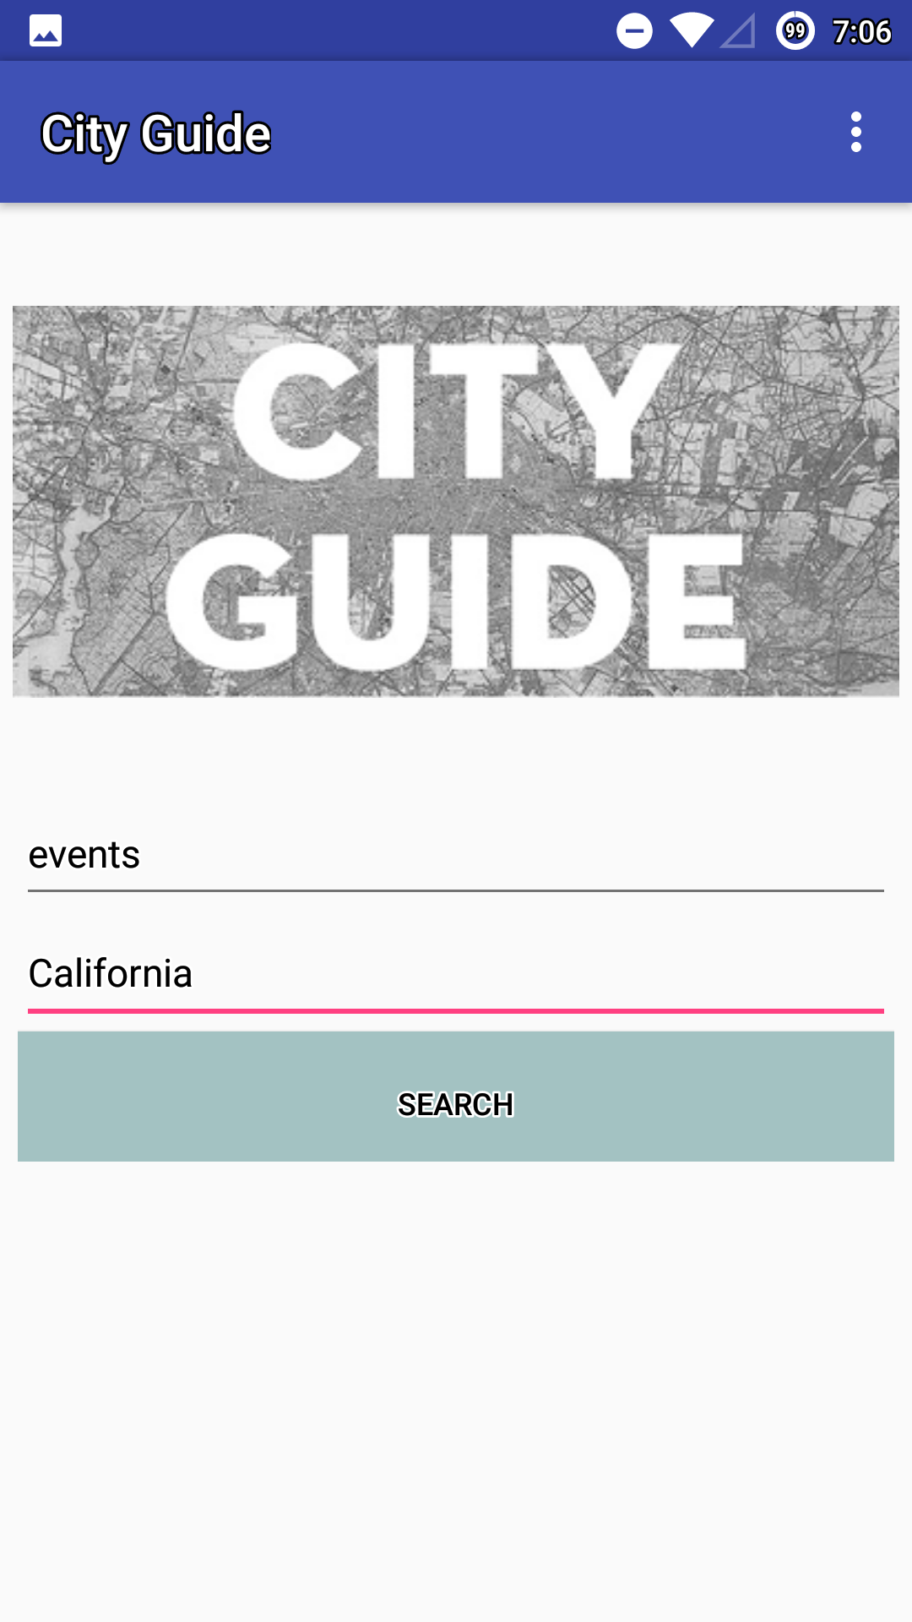

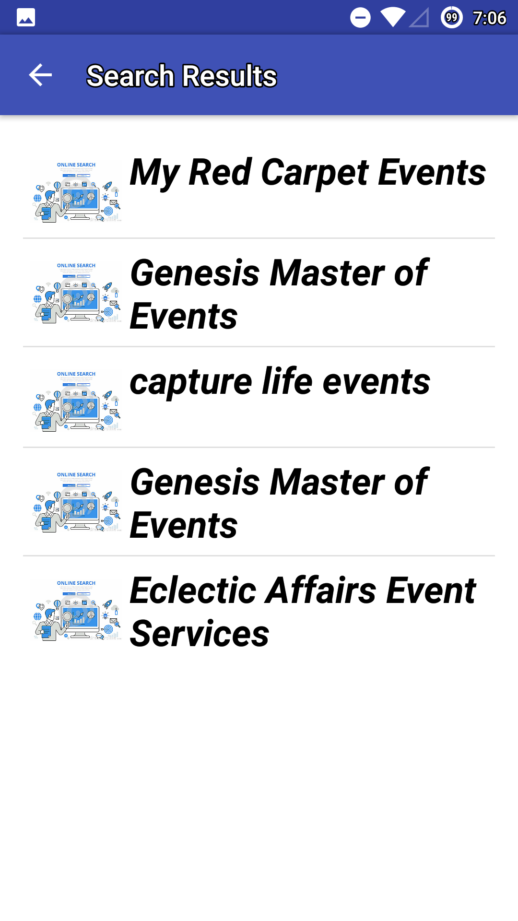

**“M-Lab Screenshots:”**

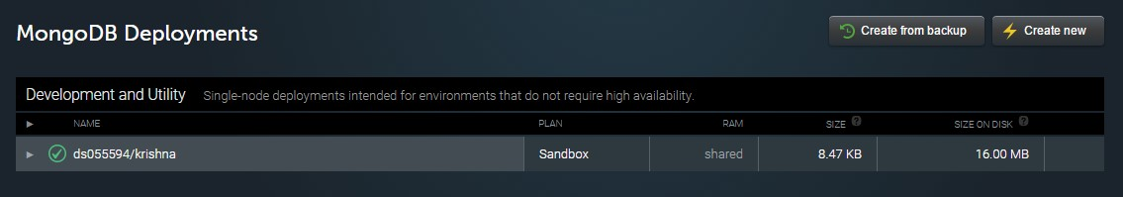

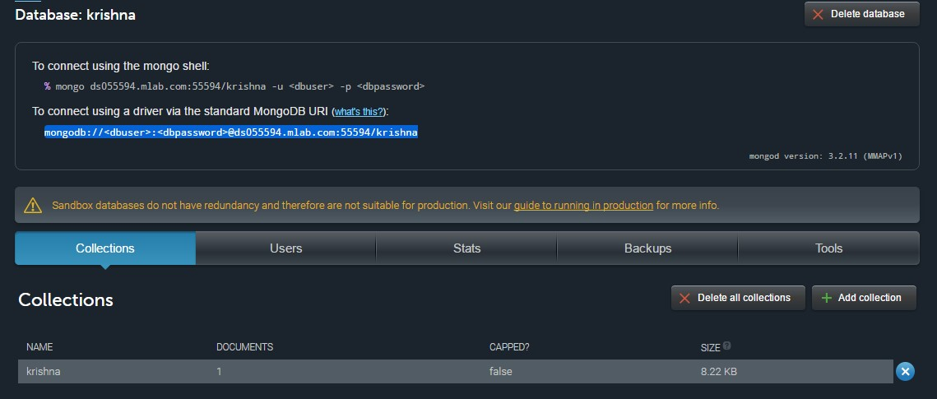

**“GitHub Wiki Link:”**

<https://github.com/OnicaRayineedi/ASE_Project/wiki/Project-Third-Increment>

**“6. Project Management”**

### “Implementation Status report:”

**“Technologies and Platforms used:”**

* HTML 5
* CSS 3
* JavaScript
* MongoDB
* Android Studio

**“Work Completed:”**

* Designed Architecture of the application
* Designed Login and registration pages
* Collected related information which will be used for further implementation of the Application
* Designing home page
* Database implementations

**“Responsibility and Time Taken for Increment-4:”**

* Scheduling Events: Mamatha-1hr, Onica-1hr
* Enabling Notifications: Onica-1hr, Sreelekha – 1hr
* Search-Bar Implementation: Krishna-1 ½ hr.
* Design Patterns: Onica-1/2 hr.
* Wireframes: Sreelekha-1/2 hr.
* Class Diagrams: Mamatha – 1hr.
* Design Elements: Krishna-1/2hr, Onica-1/2hr
* UI Implementations: Sreelekha-1½ hr, Mamatha-1hr, Krishna-1hr
* User Stories and test Cases: Onica-1hr, Mamatha-1hr
* Project Report: Krishna-1hr, Sreelekha-1hr

**“Contribution:”**

* 1. Onica Sai Prasanna Lakshmi, Rayineedi – 25%
  2. Venkata Krishna, Podili– 25%
  3. Mamatha Yadav, Chekuti– 25%
  4. Sreelekha Reddy Kommareddy-25%

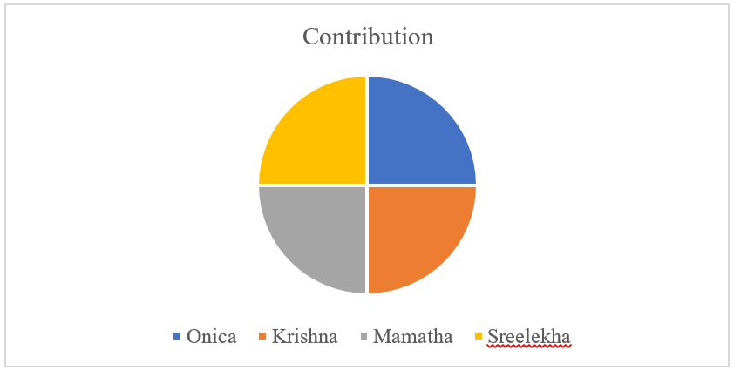

**“Bibliography:”**

* <https://creately.com/>
* [https://stackoverflow.com](https://stackoverflow.com/)
* <https://www.raywenderlich.com/109843/common-design-patterns-for-android>